Multiple-choice section

Question 1 [3.1]

If Louise ate of the donuts in this box, how many did she eat?

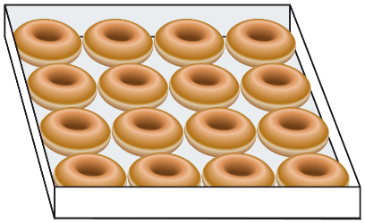

A 3 B 4 C 8 D 12

Question 2 [3.1]

Which of the following improper fractions is equal to the whole number 2?

A  B  C  D 

Question 3 [3.1]

Which of the following is closest to 1 whole?

A  B  C  D 

Question 4 [3.2]

Which of the following fractions is the simplest form of ?

A B C D

Question 5 [3.4]



A B C D

Question 6 [3.3]

The fraction  is:

A less than 1 B greater than 1, but less than 2

C greater than 2, but less than 5 D greater than 5

Question 7 [3.5]

of $35 =

A $5 B $7 C $10 D $14

Question 8 [3.6]

=

A B C 2 D 4

Multiple-choice total marks: \_\_\_\_ / 8

Short answer section

Question 9 2 marks [3.1]

Use words from the list below to complete the following sentences.

*improper fraction numerator  mixed number  unit fraction proper fraction denominator*

(a) The \_\_\_\_\_\_\_\_\_\_ is the bottom number in a fraction, below the fraction bar.

(b) A \_\_\_\_\_\_\_\_\_\_\_\_\_\_\_\_\_ has a whole number part and a fraction part.

Question 10 1 mark [3.1]

Write a fraction or mixed number to show the amount that each person receives if 1 pizza is shared equally between 7 people.

Question 11 2 marks [3.2]

Find equivalent fractions by completing the following.

(a) (b)

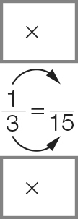 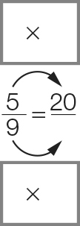

Question 12 8 marks [3.3]

For each pair of fractions:

(i) find the LCD (lowest common denominator)

(ii) write each fraction as an equivalent fraction with the LCD

(iii) insert a > (greater than), < (less than) or = (equal to) symbol between them

(iv) insert a > (greater than), < (less than) or = (equal to) symbol between the original fractions.

|  |  |
| --- | --- |
| (a), | (b) , |
| (i) LCD = \_\_\_\_ | (i) LCD =\_\_\_\_ |
| (ii) = | (ii) = |
| = | = |
| (iii) \_\_\_\_ | (iii) \_\_\_\_ |
| (iv) So \_\_\_\_ | (iv) So \_\_\_\_ |

Question 13 9 marks [3.4]

Complete the following. Write your answers in simplest form and as mixed numbers, if possible.

|  |  |  |
| --- | --- | --- |
| (a)  + | (b) – | (c) |
| =  + | =  − | =  + |
| = | = | = |
|  | = (simplify) | = 1 (mixed number) |

Question 14 6 marks [3.5]

Calculate the following. Write your answers in simplest form.

|  |  |  |
| --- | --- | --- |
| (a) of $20 | (b) of | (c) |
| = | = | =  = |
| = \_\_\_\_\_ |  |  |

Question 15 6 marks [3.6]

Complete the following. Write your answers in simplest form and as mixed numbers, if possible.

|  |  |  |
| --- | --- | --- |
| (a) 2 ÷ | (b) ÷ | (c) ÷ 3 |
| = × | = × | = × |
| = | = | = |
| = \_\_\_\_ | = 1 (mixed number) |  |

Short answer total: \_\_\_\_\_\_\_ /34

Extended answer section

Question 16 5 marks [3.1, 3.4, 3.5]

A washing line has four plain socks, four stripy socks and four spotty socks.

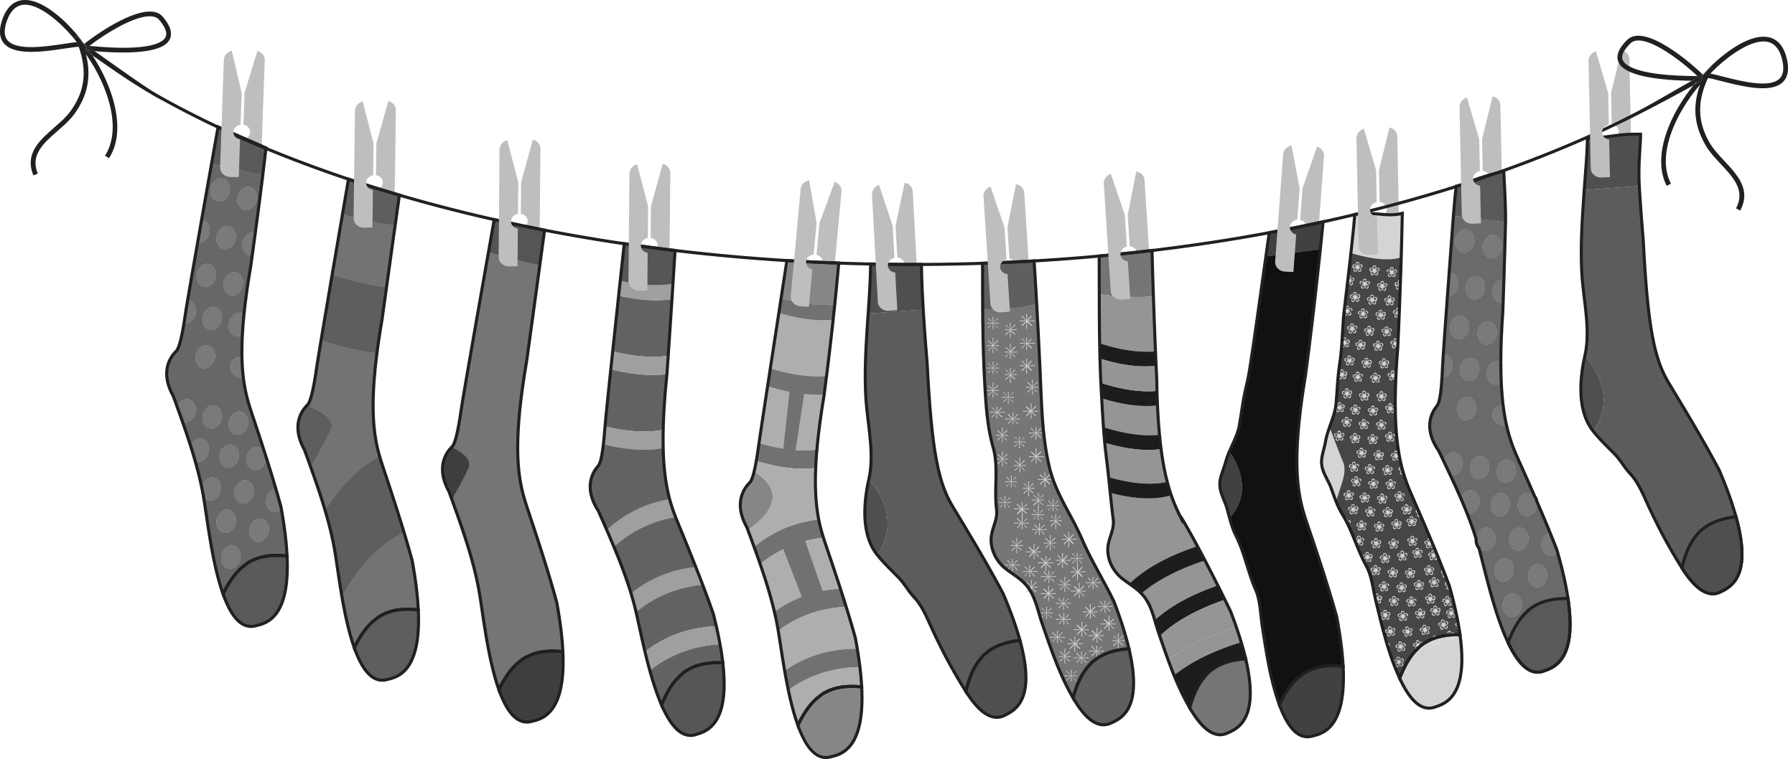

Give your answers to the following in simplest form.

(a) What fraction of the total number of socks are:

(i) spotty

(ii) stripy or plain

(b) What fraction of the total does one pair of socks represent? Write your answer in simplest form.

(c) If of the socks were removed from the line, how many would be left?

Question 17 9 marks [3.1, 3.2, 3.3]

(a) Use arrows to indicate the position of the following fraction or mixed numbers on the number line below:

, , , 

Macintosh HD:Users:lizwaud:Desktop:PM7_eBook:Batch 1 commenced:Artwork_CORRECTED_041016_Use this:Ch3:PM2e_07_EB_03_FAT_04.jpg

(b) Write the mixed numbers in the list in (a) as improper fractions.

(c) Use the number line above to help you write the whole number 2 as an improper fraction with a denominator of:

(i) 4 (ii) 8

(d) Which of the fractions you have placed on the number line would be closest to ?

(e) Place this list of fractions in ascending order (from smallest to largest). You could use the number line above to help you compare the sizes of fractions in the list.

, ,, 

Extended answer total: \_\_\_\_\_\_\_ / 14

TOTAL test marks: \_\_\_\_\_\_\_ / 56